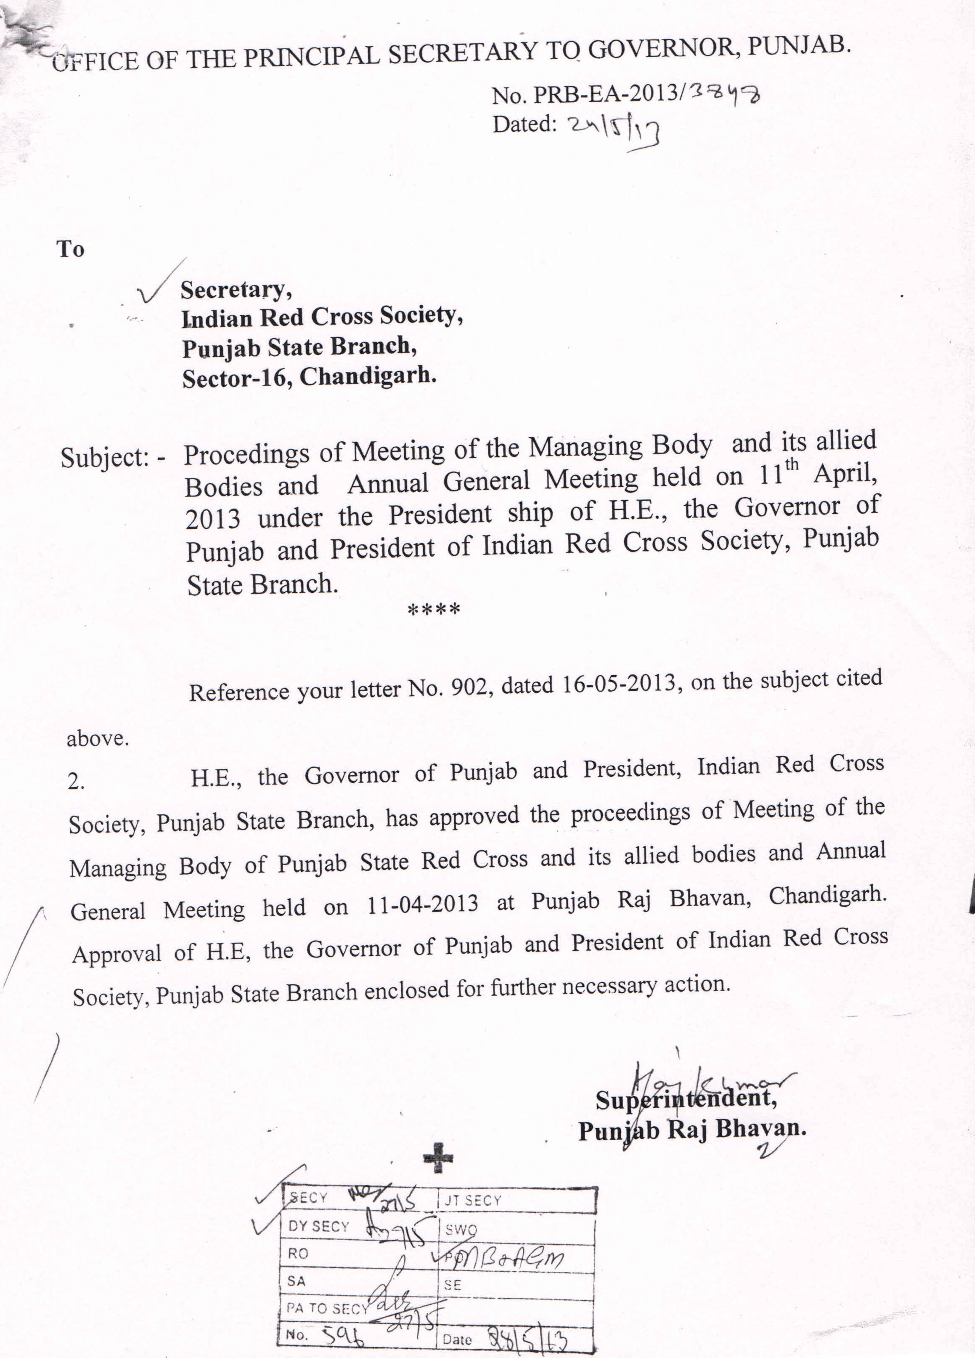

PROCEEDINGS OF THE
47TH ANNUAL GENERAL MEETING OF INDIAN RED CROSS SOCIETY, PUNJAB STATE BRANCH
ST. JOHN AMBULANCE, PUNJAB STATE CENTRE
PUNJAB STATE RED CROSS HOSPITAL WELFARE SECTION

MEETING HELD

On Thursday,Dated 11th April,2013 at 1.00 .P.M.

At Punjab Raj Bhawan

Presiding over The Annual General Meeting , His Excellency ,The Governor of Punjab and President of the Punjab State Branch and its allied organisations thanked all the delegates and social workers for their compassion for the Red Cross Movement.
Thereafter agenda items were taken up:-
Proposal | Resolution
Agenda Item No 1.  Presentation of combined Annual Report of Punjab State Branch of Indian Red Cross Society, St. John Ambulance, Punjab State Centre, Punjab State Red Cross Hospital Welfare Section for the year 2008-09, 2009-10, 2010-11 & 2011-12 | Adopted.
Agenda item No.2.  Presentation and adoption of Annual Audited Accounts for the year 2008-09,2009-10,2010-11 & 2011-12 :-  a) Punjab State Red Cross Branch;  b) Punjab State Centre of St .John Ambulance ;and  c) Punjab State Red Cross Hospital Welfare Section. | Adopted.
Agenda Item No.3.  Appointment of Sh J.B. Bhasin, Chartered Accountant of Chandigarh as Auditors to audit accounts of Punjab State Red Cross Branch, Punjab State Centre of St. John Ambulance and Punjab State Red Cross Hospital Welfare Section for the next two years i.e.2012-13, 2013-14. | Approved. H.E. desired that it may be ensured that in future the approval in this regard be obtained annually in the A.G.M.
Agenda item No4.  To approve the election of nine members as per provision contained in Article 16(d) of the Constitution for next two years. | The election of 9 members held through ballot paper. After counting of votes, the following nine members were elected :-  Sr.No. & Name Distt.  1.Sh Lakhpat Rai Barnala.  2.Sh Ashok Sachar Faridkot  3.Sh.H.S.Kareer Patiala  4.Sh.D.S.Deol,Advocate Ropar  5.Sh.Ravi Kant Gupta Ferozepur.  6.Sh.H.S. Bedi Gurdaspur.  7.Sh.Gurmeet Singh Walia Mohali  8.Sh.Tanu Aggarwal Bathinda  9.Sh.Satya Parkash Fatehgarh Sahib.  Approved.
Item No.5  To nominate four members of the Managing Body by the President for a period of two years. | His Excellency, the Governor of Punjab and President of I.R.C.S. Punjab State Branch, has nominated the following four outstanding personalities as member on Managing Body:-  1.Sh.Ramesh Inder Singh, I.A.S. (Retd.)  Chief Information Commissioner, Punjab.  2.Sh.Jugraj Singh Gill, Prominent Social Worker & Former M.L.A.  3.Mrs. Jaswant Kaur, President, Baba Sheikh Farid Blood Donors, Council, Mohali.  4.Dr.Parminder Kaur, Ph.D (Management) Principal, S.S.D. Girls College, Bathinda.  (Approval received vide Punjab Raj Bhawan letter No. PRB-EA-2013/2367 dated 02-04-2013.  (Copy at Annexure ’A’)
Item No.6  Nomination of 4 Social Workers by Distt. Branches in alphabetical order for a period of one year each. | Distt. Red Cross Branches of Patiala, Ropar, Sangrur and Tarn Taran in Alphabetical order have recommended one Social Worker each from their respective Distts. The details may kindly be seen at Annexure ‘B’.  Approved.
Item No7  Presentation of Awards to accredited Social Workers who have done commendable work in the field as approved by the Awards Committee. | His Excellency, the Governor of Punjab and President of I.R.C.S. awarded the prizes to the accredited Social Workers and to those who did commendable work as per list annexed at Annexure ‘C’.
Item 7 A  Amendments in Constitution of Indian Red Cross Society, Punjab State Branch.  Article 16 (b) (ii)  ‘For’ “The Distt. Branches will nominate their representative for State Red Cross Advisory Council as below :-  - Amritsar 7 g) Jalandhar 6  - Bhatinda 5 h) Kapurthala 2  - Faridkot 5 i) Ludhiana 6  - Ferozpur 5 j) Patiala 6  - Gurdaspur 5 k) Ropar 3  - Hoshiarpur 5 l) Sangrur 5  “Read”  - Amritsar 5 l) Ludhiana 6  - Bhatinda 5 m) Moga 3  - Barnala 3 n) Mukatsar 3  - Faridkot 5 o) Mansa 3  - Ferozpur 5 p) Mohali 3  - Fazilika 3 q) Nawanshehar 3  - F.G. Sahib 3 (SBS Nagar)  - Gurdaspur 5 r) Patiala 6  - Hoshiarpur 5 s) Pathankot 3  - Jalandhar 6 t) Ropar 3  - Kapurthala 2 u) Sangrur 5  v) Taran Taran 3  Note :- This amendment is necessitated due to increase in Distts. in the State.  Functions of the Managing Body.  Article 27(v)  ‘For’ To appoint the Secretary of the State Branch, to determine his powers and duties and to fix his salary or emoluments. All other appointments shall be made by the Vice- Chairman on the recommendations of the Secretary.  ‘Read’ To appoint the Secretary of the State Branch, to determine his powers and duties and to fix his salary or emoluments. All other appointments should be made by the Secretary except the post of Deputy Secretary. The appointment for the post of Deputy Secretary shall be made by the Vice- Chairman.  Note :- This amendment is necessitated due to the reason that “The Indian Red Cross Society, Punjab State Branch, St. John Ambulance Association, Punjab State Centre, Punjab State Red Cross Hospital Welfare Section and Punjab Saket Rules, 1996 had been amended with the approval of the Managing Body in its meeting held on 11th December, 2008.  The amendment to Rule 7 of the ibid rules reads as under after amendment:-  Rule 7. Appointing authority for all the staff members of the Society except the post of Deputy Secretary would be the Secretary of the Society. Appointing Authority in respect of Deputy Secretary would be Vice-Chairman of the Society. The Appointing Authority for the post of Secretary would be the President of the Society as per existing terms and conditions.  Miscellaneous  Article 30 (d)  For:- The Secretary shall have power to incur expenditure not exceeding Rs. 20,000/- on any single item provided it is a routine item of expenditure involving no departure from settled policy and the sum involved is included in the budget estimate. In emergent situation he may spend Rs. 50,000/- at a time.  ‘Read’ The Secretary shall have power to incur expenditure not exceeding Rs. 1,00,000/- on any single item provided it is a routine item of expenditure involving no departure from settled policy and the sum involved is included in the budget estimate. In emergent situation he may spend Rs. 1,50,000/- at a time.  Article 30 (e)  ‘For’:- For any single item of expenditure budgeted involving more than Rs. 20,000/- sanction of the Vice-Chairman will be obtained. For unbudgeted expenditure, Vice-Chairman may sanction expenses upto Rs. 10,000/- on any single item.  ‘Read’:- For any single item of expenditure budgeted involving more than Rs. 1,00,000/- sanction of the Vice-Chairman will be obtained. For unbudgeted expenditure, Vice- Chairman may sanction expenses upto Rs. 50,000/- on any single item.  Powers of President to sanction expenditures  Article 30 (f)  ‘For’ :- Expenditure involving more than Rs. 10,000/- not provided in the Budget may be sanctioned by the President.  ‘Read’ :- Expenditure involving more than Rs. 50,000/- not provided in the Budget may be sanctioned by the President.  Note:- These amendments are necessitated due to rise in prices.  For favour of approval pl. | Approved  This amendment was deferred by H.E. and desired that it will be considered later on.  Approved  Approved  Approved  Approved

DR. Ashok Nayyar, Director ,Health Services, Punjab and Vice-Chairman ,I.R.C.S. Punjab State Branch presented Vote of Thanks.
.

Secretary.

